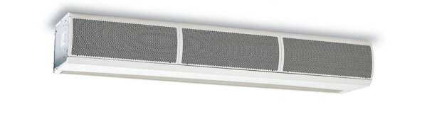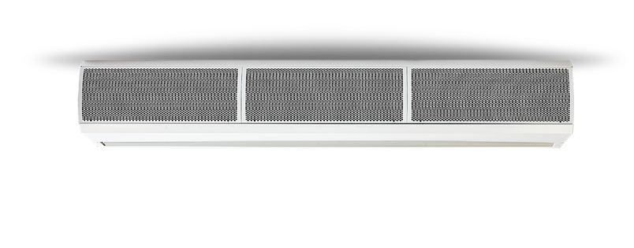Specification Text / Tender Text

PHV Series - Surface Mounted
A powerful solution for high-velocity applications.

Coils
Units with water heating coils are manufactured from copper tube, mechanically expanded to die cut aluminium fins with female BSP connections. Factory tested to 20 bar air under water testing and rated for working pressures of up to 8 bar. Externally mounted mid-position valve offers no heat (ambient), half heat or full heat settings.

Casing
Surface mounted units have pressed curved front access panel with a punched air inlet grille to the top. The casing is fabricated out of 1.0mm laminated steel construction contoured to prevent distortion and drumming.

Outlet / Discharge Grills
The discharge grille is an extruded aluminium teardrop profile that allows deflection of the air stream to either the inside or outside of the building to overcome external pressures.

End Caps
Injection moulding endcaps are push fitted onto the ends of the unit to give a cover any exposed faces. Endcaps are typically colour matched with the unit with alternative colours available on request.

Filters
Reticulated limited-reusable foam filters reduce the ingress of dirt and dust protecting the unit’s internals.

Fans
Each unit has a factory balanced tangential fan powered by a 4 pole AC split phase capacitor motor with integral thermal protection. The high specification motors incorporate “sealed for life” bearings, are anti-vibration mounted to give an expected life in excess of 40,000 running hours. Connection is via a plug in connector in the unlikely event of needing to be removed.
Controls
The PHV Series uses a factory installed intelligent, controller with the following features included:
- Multiple fan speed selection - 3 speeds available
- Multiple heating level selection - 3 levels available (Water and Electric units only)
- Dry contact for supervisory system connection or door switch
- Programmable input for air temperature thermostat
- Thermal protection reset
- Master/slave control
- Wall Controller - Durable injection moulded ABS housing, contains the printed circuit board. Rubberised buttons to provide user adjustment of 3 fan speeds, 3 heat levels, on/off switch and automatic/manual heating control.
- Optional Modbus and Bacnet interface module for easy connection to a BMS
system.
Electric Heating Elements (Electric Units Only)
Factory installed and wired, thermally protected and constructed with a galvanised steel frame, with helical coil suspended elements. Elements are typically powered with 3 phase with single phase options available on request.

Wall Mounting Bracket (Optional and For Surface Units Only)
Cold rolled mild steel powder coated wall bracket finished to colour match the unit’s casing to allow installation of the unit in line with the installation instructions.
Ceiling Mounting Bracket ((Optional and For Surface Units Only)
The unit is supplied with M10 threaded fixings on the top face to allow installation with M10 threaded drop rods.

IF YOU ARE LOOKING FOR MORE INFORMATION YOU CAN ASK OUR DEDICATED TEAM OR DOWNLOAD OUR BROCHURE AND MANUAL.

CLICK TO SPEAK TO TEAM CLICK TO DOWNLOAD THE BROCHURE
CLICK TO DOWNLOAD THE MANUAL

+44 (0) 24 7638 4646

SALES@THERMOSCREENS.COM WWW.THERMOSCREENS.COM
Thermoscreens Limited St Mary’s Road, Nuneaton, Warwickshire CV11 5AU

Part of

