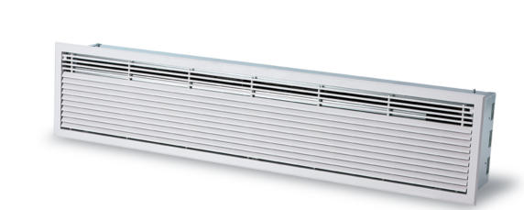

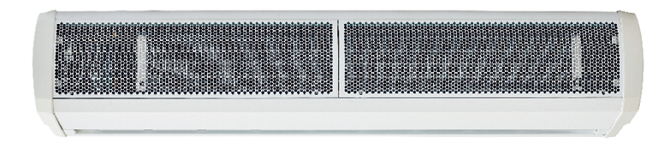Specification Text / Tender Text

C Series - Surface & Recessed Mounted
An affordable solution for applications where space is at a premium.

Coils

Coils are manufactured from copper tube, mechanically expanded to die cut aluminium fins with female BSP connections. The coils are rated to a working pressure of 8 bar, however, to make sure each coil meets strict quality criteria, they are factory tested to 20 bar using under watertesting. An externally mounted mid-position valve offers no heat, half heat or full heat settings.

Casing

Surface mounted units have pressed curved inlet grilles that function as a sectional access panel. The casing is fabricated out of 1.0mm laminated steel, which is contoured to prevent distortion and drumming. Installation of the air curtain is performed by using M6 threaded rods from the top of the unit.

Recessed mounted units have a galvanised enclosure with a powder coated aluminium grille that serves as an access panel for maintenance. Installation is unchanged and is conducted by using M6 threaded rods from the top of the unit.

Fans

Each unit has a tangential fan powered by a 4 pole AC split phase capacitor motor with integral thermal protection. The high specification motors incorporate “sealed for life” bearings, that are mounted to reduce the amount of vibration, giving an expected life in excess of 40,000 running hours. Connection is via a simple plug-in connector, making removal quick and easy for maintenance and in the unlikely event of a replacement.

Controls

The C Series uses a factory installed intelligent, controller with the following features
included:
- Multiple fan speed selection - 3 speeds available
- Multiple heating level selection - 3 levels available (Water and Electric units only)
- Dry contact for supervisory system connection or door switch
- Programmable input for air temperature thermostat
- Thermal protection reset
- Master/slave control
- Wall Controller - Durable injection moulded ABS housing, contains the printed circuit board. Rubberised buttons to provide user adjustment of 3 fan speeds, 3 heat levels, on/off switch and automatic/manual heating control.
- Optional Modbus and Bacnet interface module for easy connection to a BMS
system.

Electric Heating Elements (Electric Units Only)

Housed in a galvanised steel frame, thermally protected and constructed with helical coil point suspended elements. Supply should be 3 phase.

Wall Mounting Bracket (Optional and For Surface Units Only)
Cold rolled mild steel powder coated wall bracket finished to colour match the unit’s casing to allow installation of the unit in line with the installation instructions.

IF YOU ARE LOOKING FOR MORE INFORMATION YOU CAN ASK OUR DEDICATED TEAM OR DOWNLOAD OUR BROCHURE AND MANUAL.

CLICK TO SPEAK TO TEAM CLICK TO DOWNLOAD THE BROCHURE
CLICK TO DOWNLOAD THE MANUAL

+44 (0) 24 7638 4646

SALES@THERMOSCREENS.COM WWW.THERMOSCREENS.COM

Part of

Thermoscreens Limited St Mary’s Road, Nuneaton, Warwickshire CV11 5AU

