Touch Controller

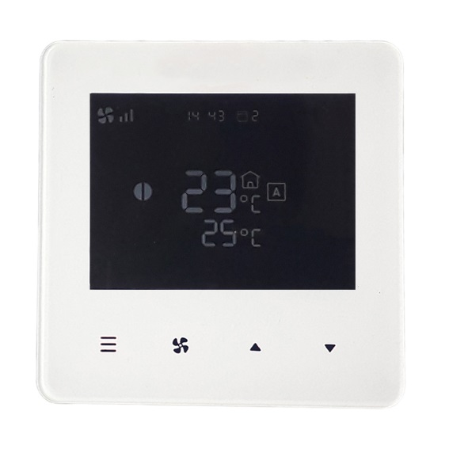

Home

Speed

Up

Down

Controller connected via RJ communications lead to CCS v10 board with Home, Speed, Up and Down touchpads below the LCD screen as detailed above.

On/Off

Press and hold Home touchpad for 2 seconds to turn air curtain ON or OFF.

**NOTE:** If an electric heated air curtain is heating when switched off the fan will run-on for approximately 2 minutes to dissipate excess heat.

Manual/Automatic

With Controller turned ON tap Home touchpad to switch between Automatic and Manual mode.

The screen displays either for Auto Mode” or for “Manual Mode”.

Heating level control

Manual mode

Select heating level and cycle between zero, half heat and to full heat with each short Up or Down touchpad press.

Automatic mode

Heat output is controlled automatically according to inlet air and the desired temperatures. The inlet air temperature is the upper temperature indication on the Controller adjacent to on the LCD screen.

Fan speed

Short press Switch touchpad to switch and cycle fan speed:



* low



* Medium



* High

Date and Time Settings

Configure Date and Time settings either via App or on Controller as below.

Turn Controller ON and hold Speed touchpad for 2 seconds

Follow instructions on LCD screen with:

* Tap Up touchpad to increase value
* Tap Down touchpad to decrease value
* Tap Speed touchpad to confirm values

Optional Control Settings

Controller with four default software Flag settings provide following optional features, as Table 1.

Table 1

|  |  |  |  |  |
| --- | --- | --- | --- | --- |
| **Flag** | **Feature** | **Explanation** | **Default** | **Notes** |
| 1 | Reset on power-up | On restoring power after an electrical interruption all Controller settings are retained | 01  (ON) | **WARNING!** – Fans start on their own after power is restored |
| 2 | Stop fan on cold | Fans are switched off when heating level is achieved (AUTO mode only) | 00  (OFF) |  |
| 3 | Never blow cold | Air curtain always heats in AUTO mode | 00  (OFF) | Will not go to ambient mode |
| 4 | Room air temperature control | Enables the room air sensor in the Remote Control | 00  (OFF) | Disables all other temperature sensors |

If required, software Flag values can be changed by entering advanced settings as below.

With Controller ON, long press both Up and Down touchpad – 01 Flag menu displayed on screen

Tap Home touchpad to detail Flag 01 Reset on powerup

Follow instructions on LCD screen with:

* Tap Speed touchpad to cycle Flags 1 to 4
* Tap Up or Down touchpad to change selected Flag value
* Tap Home touchpad to confirm value

Overheat Safety cut-out

An overheat fault in electric heated units may cause the overheat safety cut-out(s) to operate.

This is indicated by flashing warning symbol on Controller and red status LED on CCS v10 board inside the air curtain.

Before resetting ensure there is adequate air flow from the air curtain and the unit has been commissioned as per instructions.

To reset a overheat safety cut-out:

**Step 1** Switch off the electrical supply to the air curtain.

**Step 2** Allow time for the air curtain to cool down, typically 10 minutes.

**Step 3** Switch on the electrical supply to the air curtain.

**Step 4** If Controller is switched off, press and hold Home button for 2 seconds

to turn Controller ON.

**Step 5** Press the Home touchpad on Controller 8 times.

Air curtain heaters will then operate after 30 seconds with no warning symbol on Controller and flashing green status LED on CCS v10 board.